SIT103 – DATABASE FUNDAMENTALS
SELECT QUERIES WITH JOIN 6.1P
- Write a SQL statement to list invoices with their INV_NUMBER, INV_DATE along with the CUS_FNAME and CUS_LNAME of the customers they belong to.
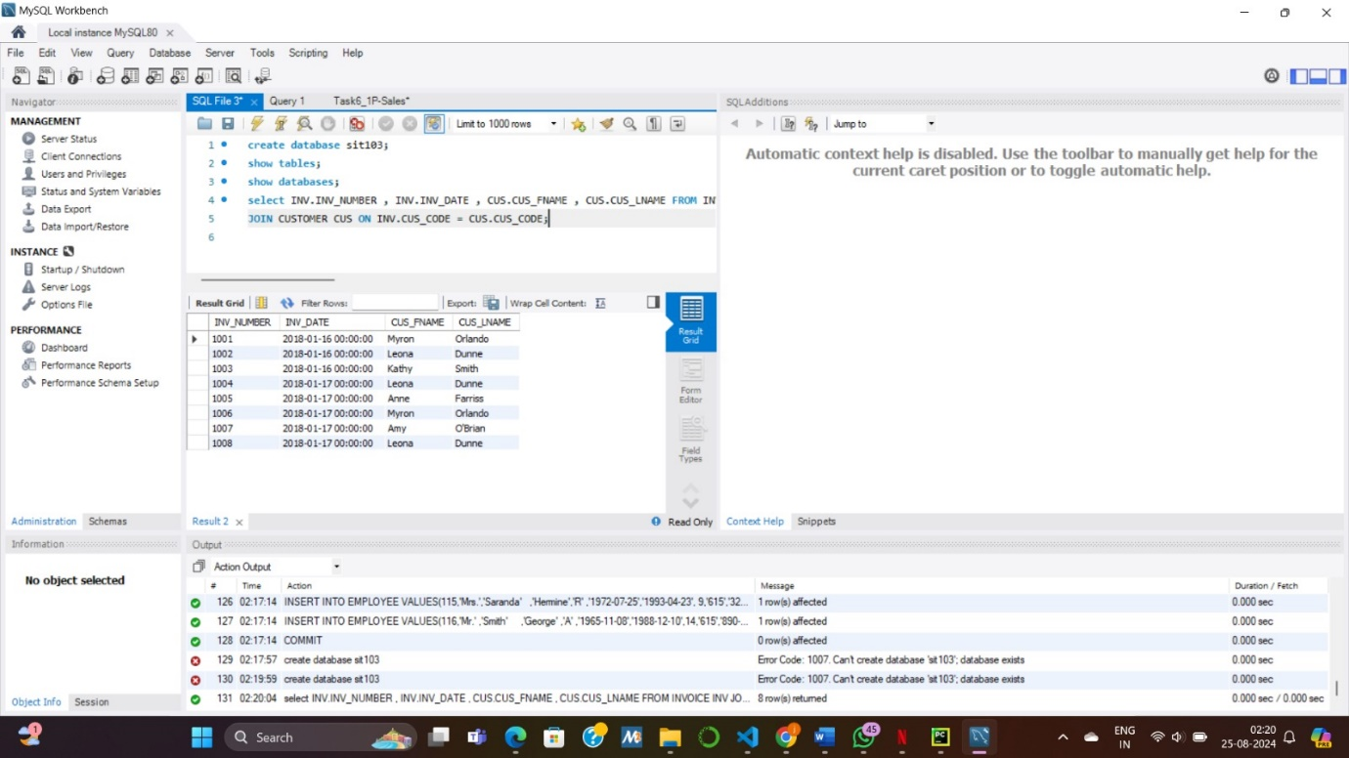
- Write a SQL statement to list V_CODE and V_NAME along with the number of products they supply (column name as ‘NUM_PRODS’) and the average price of product they supply (column name as ‘AVG_PROD_PRICE’).
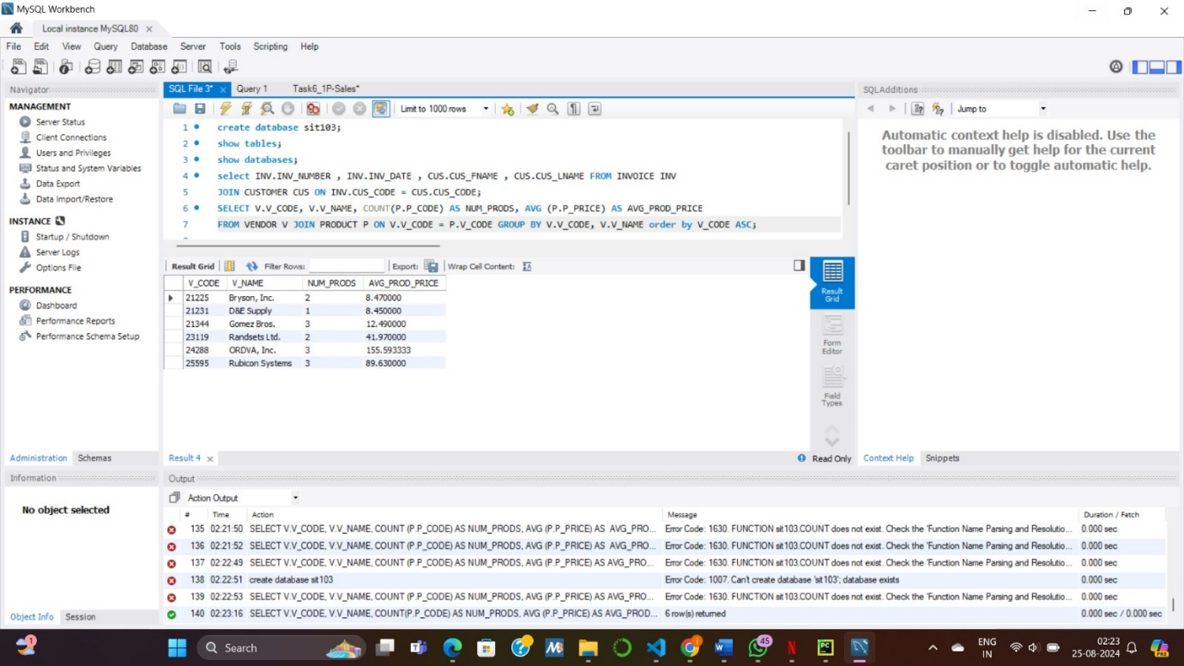
- Write a SQL statement to list P_CODE and P_DESCRIPT of all products along with their vendors’ V_CODE and V_NAME if available. Note that your results must include all products regardless of whether vendor information is available or not. For products where vendor information is not available, V_CODE and V_NAME columns will be empty or NULL in the result (Hint: use outer join).
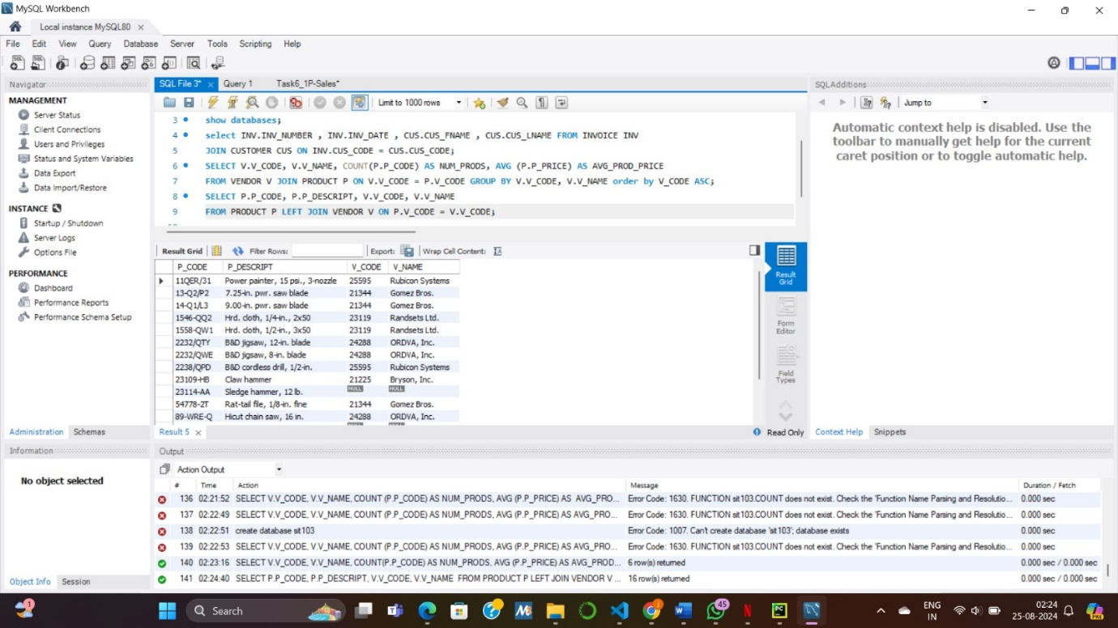
- Write a SQL statement to retrieve INV_DATE and the list of products with P_CODE and P_DESCRIPT of the invoice with INV_NUMBER = 1008 (Hint: you may have to join three tables)
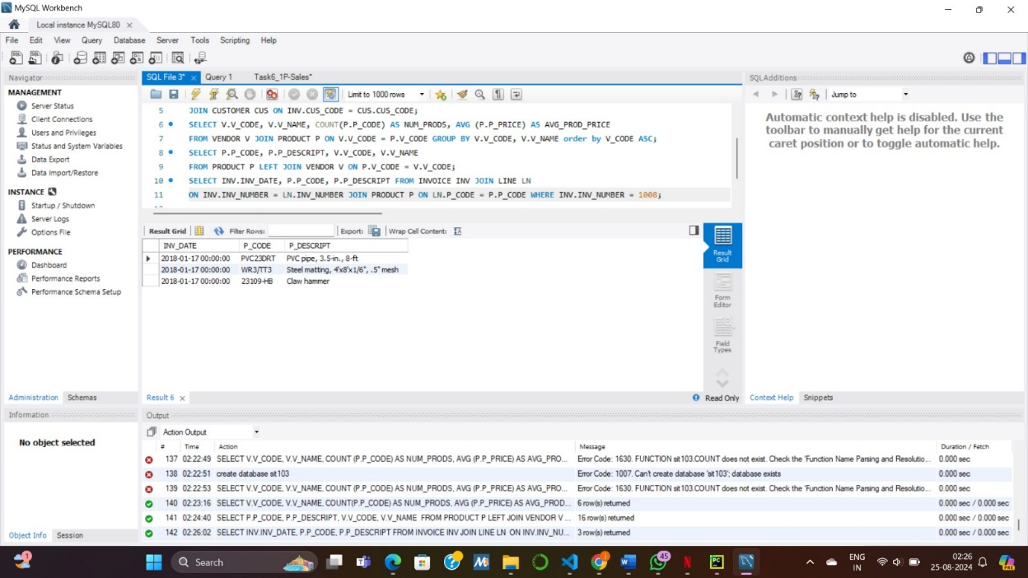
- Write a SQL statement to list full names (by concatenating EMP_FNAME and EMP_LNAME separated by a space) of employees AS ‘Employee’ with their managers’ full name (again by concatenating EMP_FNAME and EMP_LNAME separated by a space) AS ‘Manager’ (Hint: recursive/self join and string concatenation)
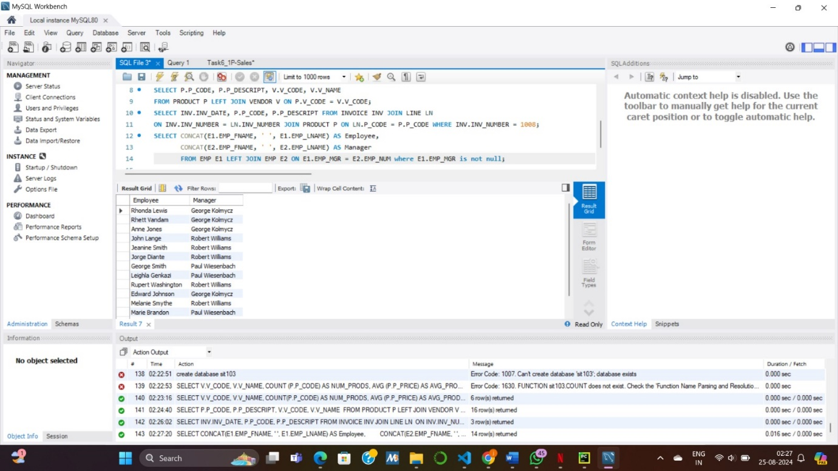
- Write a SQL statement to list P_CODE and P_DESCRIPT of products that came in store (INDATE) in the month of February of 2018.

